Pokhara University

Level: Bachelor | Semester – Fall | Year : 2011
Programme: BE |  | Full Marks: 100
Course: Engineering Mathematics III |  | Pass Marks: 45
 |  | Time : 3hrs.

Candidates are required to give their answers in their own words as far as practicable.
The figures in the margin indicate full marks.

Attempt all the questions.

 | - When does the inverse of a matrix exist? Find A⁻¹ if  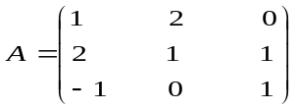  OR  If a + b + c = 0, Solve 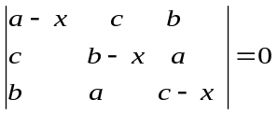  - Show that the equations x + 2y - z =3, 3x – y + 2z =1, 2x- 2y + 3z = 2 are consistent, and hence solve them. | 8  8  7
 | - Define the linearly dependent and independent vectors. Find whether the following sets of vectors are linearly dependent or independent.  (1,-1,1), (1,1 -1), (-1 1,1,), (0,1,0)  - Find Eigen value and Eigen vector of the following matrix: 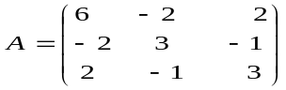 | 8  7
 | - Show that the infinite series  - Find the centre, radius of convergence and interval of convergence of the power series 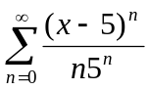 | 7  8
 | - 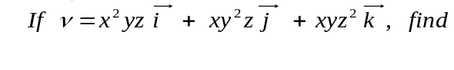  - div 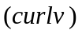and  - 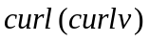  - State Green theorem. Use it to evaluate the integral 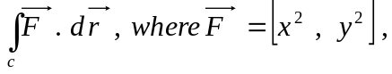 c: the square whose vertices are (0, 0), (1, 0), (1, 1) and (0, 1). | 8  7
 | - State Gauss Divergence Theorem. Using Gauss divergence theorem, evaluate the integral 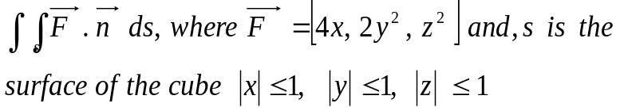  - Find the flux integral of 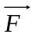= [x, y, z] through the surface S where S is the first octant portion of the plane 2x + 3y + z = 6. | 7  8
 | - If 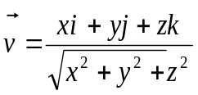find 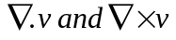  - Calculate from (0,0,0) to (2,4,8).  OR  Show that the value under the integral sign is exact and then evaluate the integral 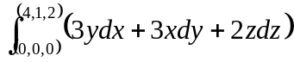 | 7  8  8
 | Answer the following questions:  - Test whether the following series is convergent or divergent 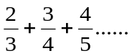  - 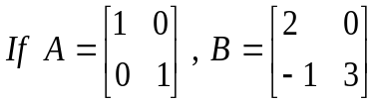 find AB and BA.  - Test the convergence and divergence of the series 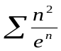  - Show that the product of two odd functions is even.  - Find the rank of 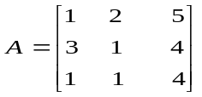 | 2  2  2  2  2

